**Assignment 10**

**Aim –** Implement the following page replacement algorithms

* FIFO
* LRU
* Optimal

In this situation, the operating system replaces an existing page from the main memory by bringing a new page from the secondary memory.

In such situations, the FIFO method is used, which is also refers to the First in First Out concept.

This is the simplest page replacement method in which the operating system maintains all the pages in a queue.

Oldest pages are kept in the front, while the newest is kept at the end. On a page fault, these pages from the front are removed first, and the pages in demand are added.

ALGORITHM

1. Start the process

2. Declare the size with respect to page length

3. Check the need of replacement from the page to memory

4. Check the need of replacement from old page to new page in memory

5. Forma queue to hold all pages

6. Insert the page require memory into the queue

7. Check for bad replacement and page fault

8. Get the number of processes to be inserted

9. Display the values

10. Stop the process

Code : FIFO

#include<stdio.h>

int main()

{

int i,j,n,a[50],frame[10],no,k,avail,count=0;

printf("\n ENTER THE NUMBER OF PAGES:\n");

scanf("%d",&n);

printf("\n ENTER THE PAGE NUMBER :\n");

for(i=1;i<=n;i++)

scanf("%d",&a[i]);

printf("\n ENTER THE NUMBER OF FRAMES :");

scanf("%d",&no);

for(i=0;i<no;i++)

frame[i]= -1;

j=0;

printf("\tref string\t page frames\n");

for(i=1;i<=n;i++)

{

printf("%d\t\t",a[i]);

avail=0;

for(k=0;k<no;k++)

if(frame[k]==a[i])

avail=1;

if (avail==0)

{

frame[j]=a[i];

j=(j+1)%no;

count++;

for(k=0;k<no;k++)

printf("%d\t",frame[k]);

}

printf("\n");

}

printf("Page Fault Is %d",count);

return 0;

}

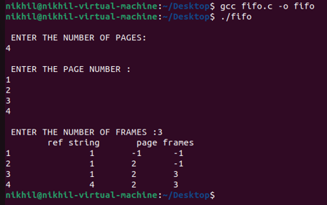

LRU

#include<stdio.h>

main()

{

int q[20],p[50],c=0,c1,d,f,i,j,k=0,n,r,t,b[20],c2[20];

printf("Enter no of pages:");

scanf("%d",&n);

printf("Enter the reference string:");

for(i=0;i<n;i++)

scanf("%d",&p[i]);

printf("Enter no of frames:");

scanf("%d",&f);

q[k]=p[k];

printf("\n\t%d\n",q[k]);

c++;

k++;

for(i=1;i<n;i++)

{

c1=0;

for(j=0;j<f;j++)

{

if(p[i]!=q[j])

c1++;

}

if(c1==f)

{

c++;

if(k<f)

{

q[k]=p[i];

k++;

for(j=0;j<k;j++)

printf("\t%d",q[j]);

printf("\n");

}

else

{

for(r=0;r<f;r++)

{

c2[r]=0;

for(j=i-1;j<n;j--)

{

if(q[r]!=p[j])

c2[r]++;

else

break;

}

}

for(r=0;r<f;r++)

b[r]=c2[r];

for(r=0;r<f;r++)

{

for(j=r;j<f;j++)

{

if(b[r]<b[j])

{

t=b[r];

b[r]=b[j];

b[j]=t;

}

}

}

for(r=0;r<f;r++)

{

if(c2[r]==b[0])

q[r]=p[i];

printf("\t%d",q[r]);

}

printf("\n");

}

}

}

printf("\nThe no of page faults is %d",c);

}

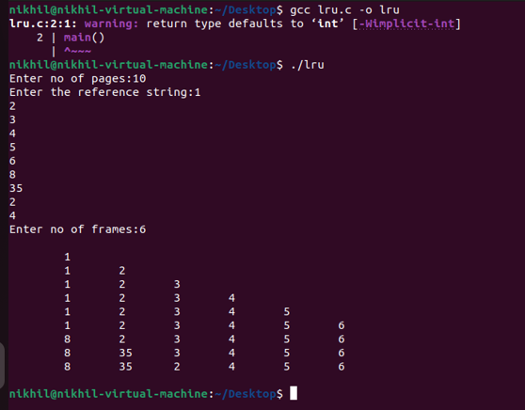

OPTIMAL :

#include<stdio.h>

int main()

{

int no_of_frames, no_of_pages, frames[10], pages[30], temp[10], flag1, flag2, flag3, i, j, k, pos, max, faults = 0;

printf("Enter number of frames: ");

scanf("%d", &no_of_frames);

printf("Enter number of pages: ");

scanf("%d", &no_of_pages);

printf("Enter page reference string: ");

for(i = 0; i < no_of_pages; ++i){

scanf("%d", &pages[i]);

}

for(i = 0; i < no_of_frames; ++i){

frames[i] = -1;

}

for(i = 0; i < no_of_pages; ++i){

flag1 = flag2 = 0;

for(j = 0; j < no_of_frames; ++j){

if(frames[j] == pages[i]){

flag1 = flag2 = 1;

break;

}

}

if(flag1 == 0){

for(j = 0; j < no_of_frames; ++j){

if(frames[j] == -1){

faults++;

frames[j] = pages[i];

flag2 = 1;

break;

}

}

}

if(flag2 == 0){

flag3 =0;

for(j = 0; j < no_of_frames; ++j){

temp[j] = -1;

for(k = i + 1; k < no_of_pages; ++k){

if(frames[j] == pages[k]){

temp[j] = k;

break;

}

}

}

for(j = 0; j < no_of_frames; ++j){

if(temp[j] == -1){

pos = j;

flag3 = 1;

break;

}

}

if(flag3 ==0){

max = temp[0];

pos = 0;

for(j = 1; j < no_of_frames; ++j){

if(temp[j] > max){

max = temp[j];

pos = j;

}

}

}

frames[pos] = pages[i];

faults++;

}

printf("\n");

for(j = 0; j < no_of_frames; ++j){

printf("%d\t", frames[j]);

}

}

printf("\n\nTotal Page Faults = %d", faults);

return 0;

}

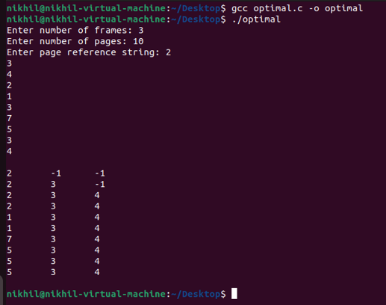

Conclusion : Hence we have successfully studied and executed the page replacement algorithm.

**THANK YOU!!!!!!!!!!**